Edge Intelligence Lab -1
M.Vishwa(25MML0039)
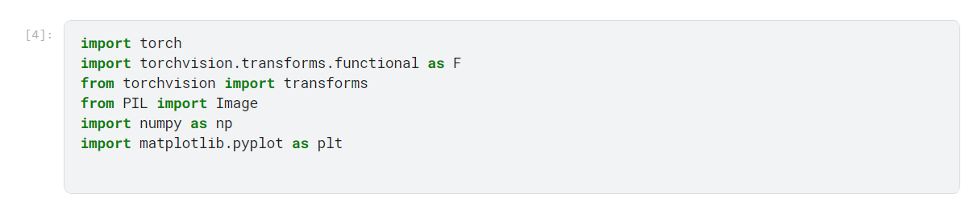
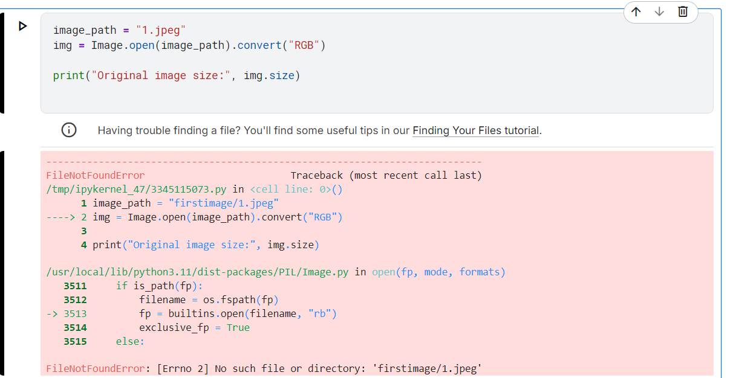
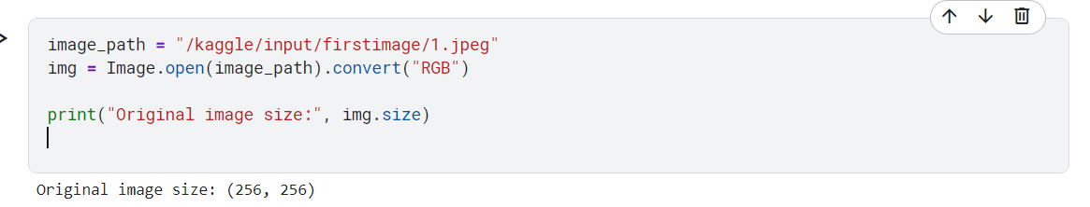
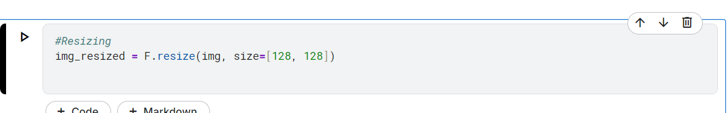
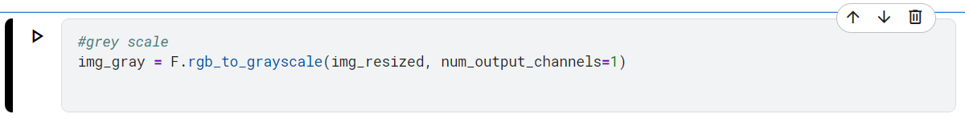
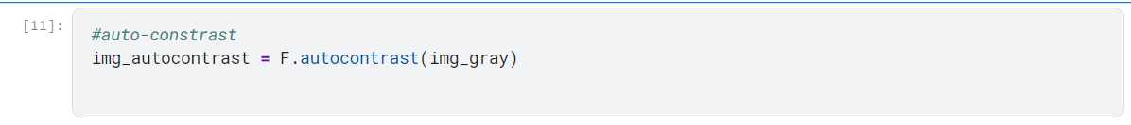
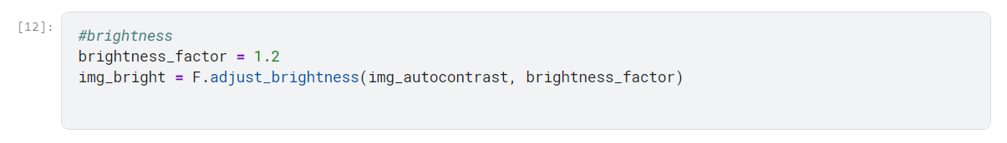
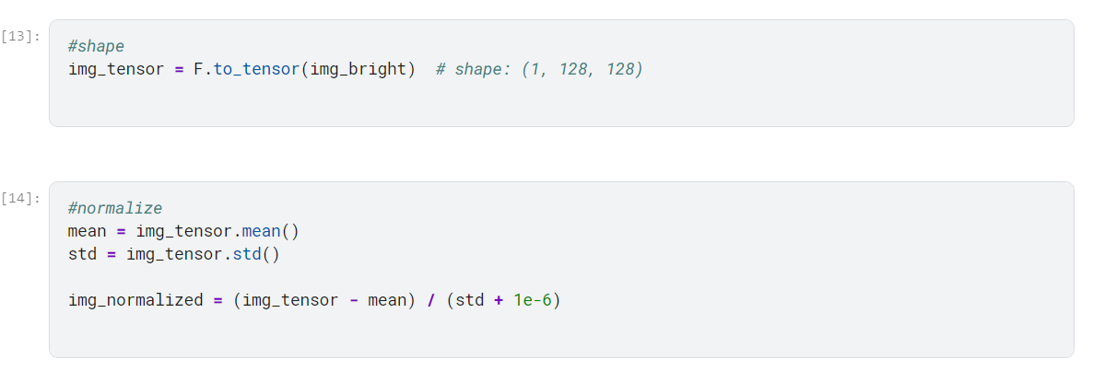
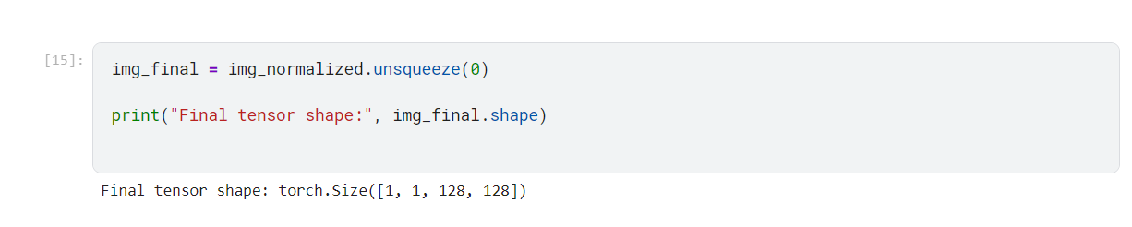
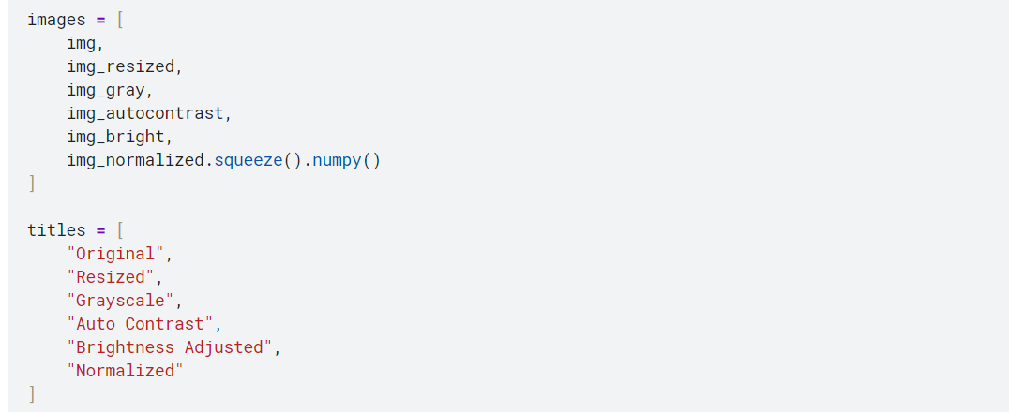
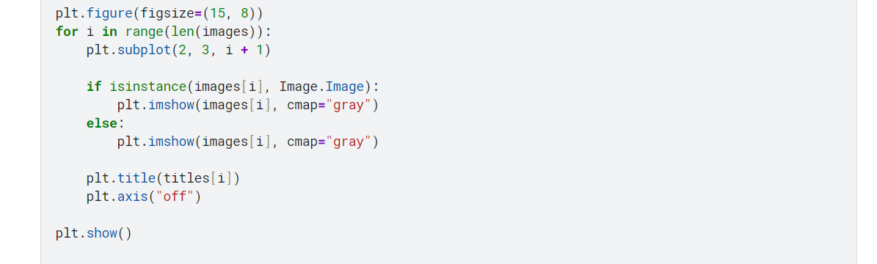
Output:
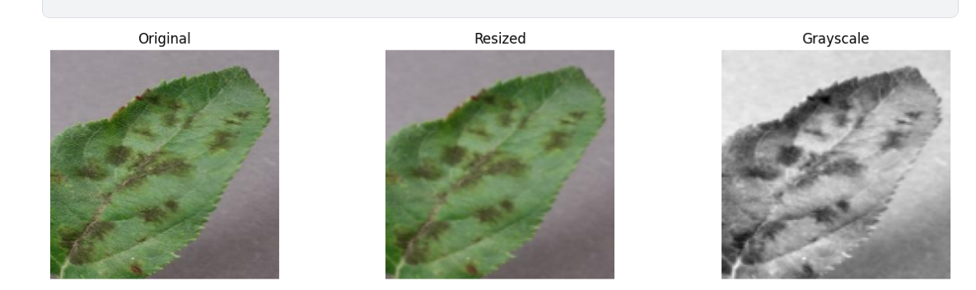
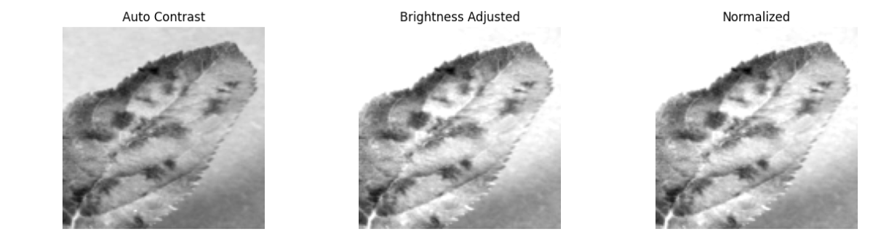

Dataset Link: https://www.kaggle.com/datasets/tushar5harma/plant-village-dataset-updated

